CDH 5.x.x Requirements

* **Operating System : Ubuntu :**  
  CDH 5.3.x runs on both Ubuntu Trusty (14.04)
* **In VM, bridged network**
* **Internet Protocol& Access :**  
  Protocol: IPv4  
  Internet access to allow the wizard to install software packages or parcels from *archive.cloudera.com*

In ubuntu, go to terminal and run:

*$ sudo su*

1. Passwordless sudo priviledge

*$ sudo visudo*

add this line -

%<username>  ALL=(ALL) NOPASSWD:ALL

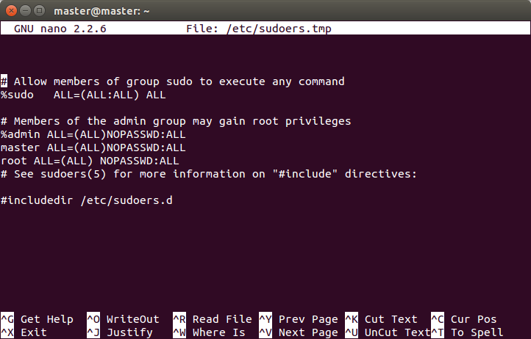

1. disable ipv6

#### Check if IPv6 is disabled

|  |  |
| --- | --- |
|  | *$ cat /proc/sys/net/ipv6/conf/all/disable_ipv6* |

**Note :**0 means it's enabled and 1 is disabled.

To disable IPv6

|  |  |
| --- | --- |
|  | *$ sudo su -*  *$ nano  /etc/sysctl.conf* |

Add these lines to sysctl.conf file

|  |  |
| --- | --- |
|  | #disable ipv6  net.ipv6.conf.all.disable_ipv6 = 1  net.ipv6.conf.default.disable_ipv6 = 1  net.ipv6.conf.lo.disable_ipv6 = 1 |

Save sysctl.conf file with new config and Reboot your system

1. fqdn server

in each node,

*$ ifconfig*

note down ip address (inet add)

*$ hostname*

(and hostname)

then in each node

*$ sudo gedit /etc/hosts*

add –

ipaddress_of_current_node hostname_of_current_node

ipaddress_of_other_node hostname_of_other_node

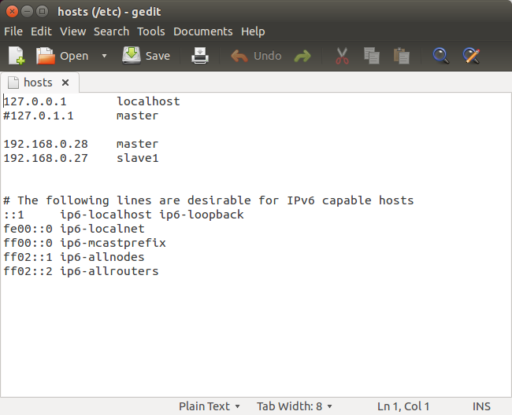

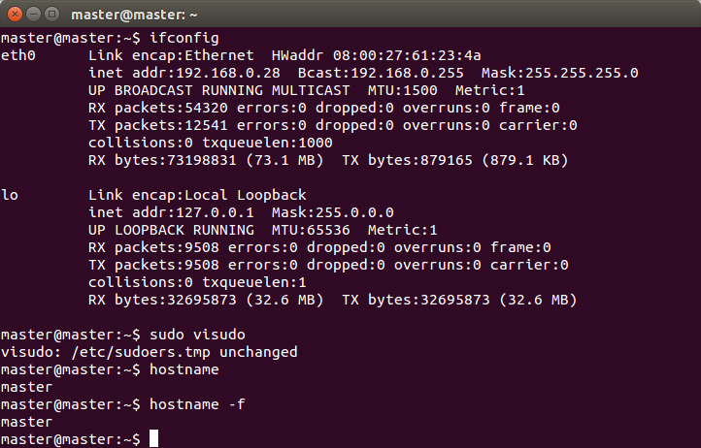

then do ping on each other

*$ ping <hostname>*

1. create ssh connection:

in each node

|  |
| --- |
| *$sudo apt-get install openssh-client*  *$sudo apt-get install openssh-server* |

#### **Configuring passwordless SSH.**

We need to configure SSH access to localhost for the user

|  |  |
| --- | --- |
|  | *$ sudo gedit /etc/ssh/sshd_config* |

**Note :**Set PubkeyAuthentication to Yes.

|  |  |
| --- | --- |
|  | *$ sudo /etc/init.d/ssh reload* |

To generate SSH key

|  |  |
| --- | --- |
|  | *$ ssh-keygen*  *$ ssh-add*  *$ sudo cat .ssh/id_pub.rsa >> .ssh/sauthorized_keys* |

in master node or namenode :

*$ ssh-copy-id –i datanode_hostname@datanode_ip_add*

do it for all datanodes with namenodes also

Now from namenode, check ssh connection with datanodes

*$ ssh hostname@ipaddress (of datanodes)*

1. add repository:

Path to repository address –

https://www.cloudera.com/documentation/enterprise/5-8-x/topics/cm_ig_install_path_b.html

In terminal

*$ sudo add-apt-repository "deb [arch=amd64] http://archive.cloudera.com/cm5/ubuntu/trusty/amd64/cm trusty-cm5 contrib"*

*$ sudo add-apt-repository "deb-src http://archive.cloudera.com/cm5/ubuntu/trusty/amd64/cm trusty-cm5 contrib"*

*$ apt-get updat*e

*$ sudo apt-get install oracle-j2sdk1.7*

Now go to cloudera download page

https://www.cloudera.com/downloads/manager/5-12-1.html

$ wget https://archive.cloudera.com/cm5/installer/latest/cloudera-manager-installer.bin

$ chmod u+x cloudera-manager-installer.bin

$ sudo ./cloudera-manager-installer.bin

1. Deploy cdh with cloudera manager :

in web browser, go to

localhost:7180

login credential:

user : admin

password: admin

1. Setting up Cluster:’

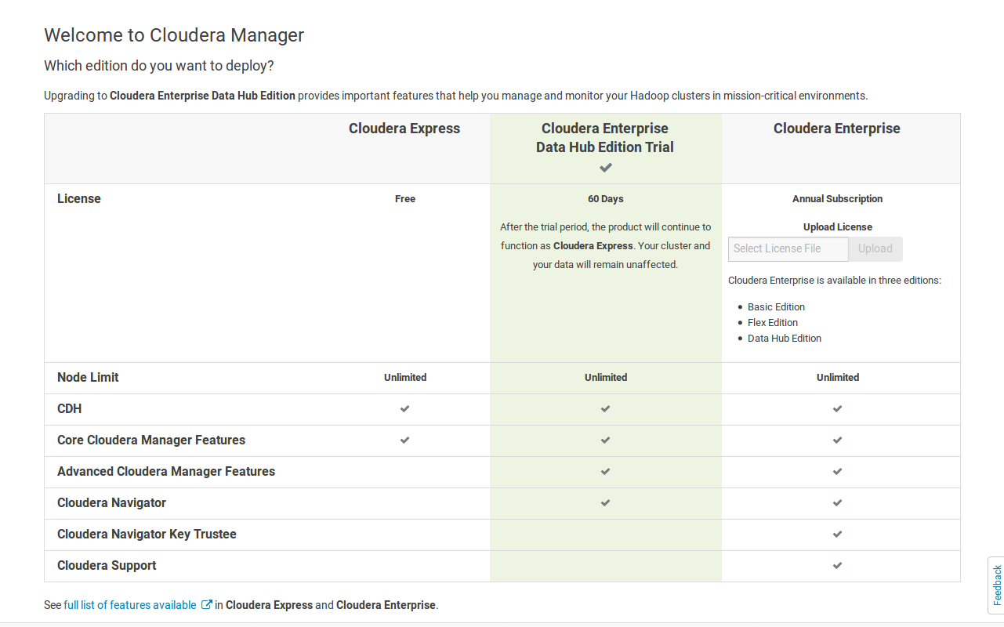

Select Cloudera Express.

Search nodes via ip

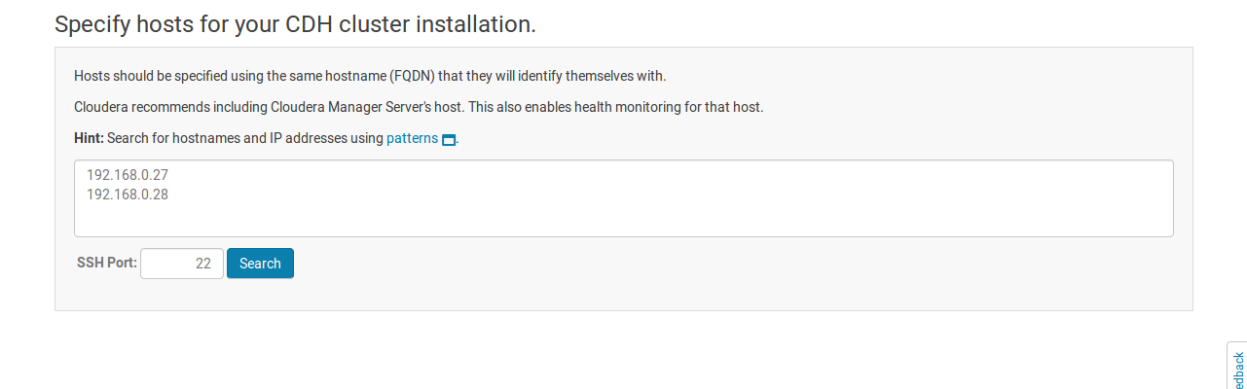

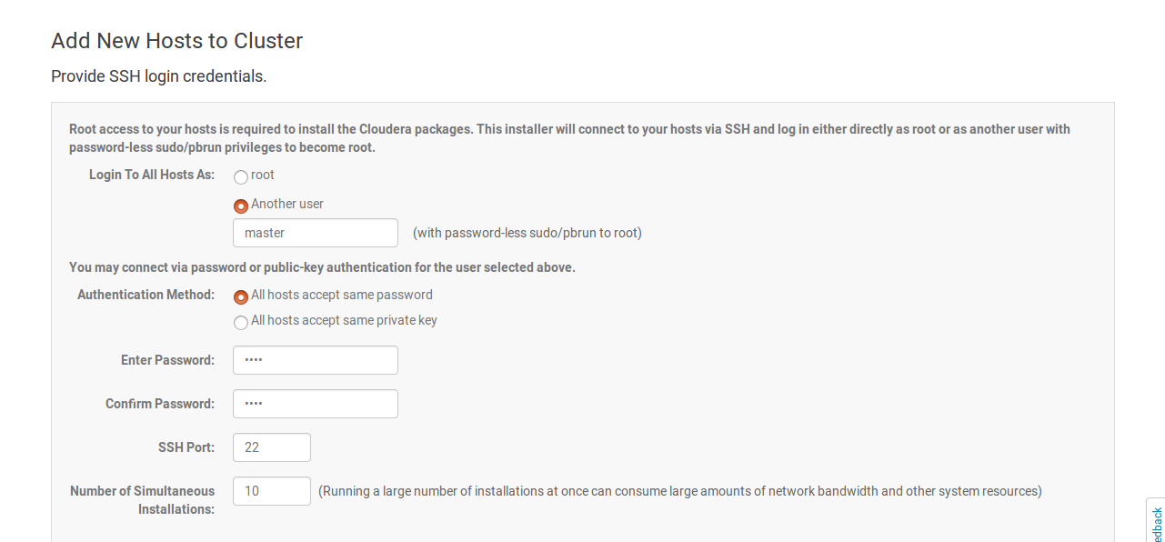

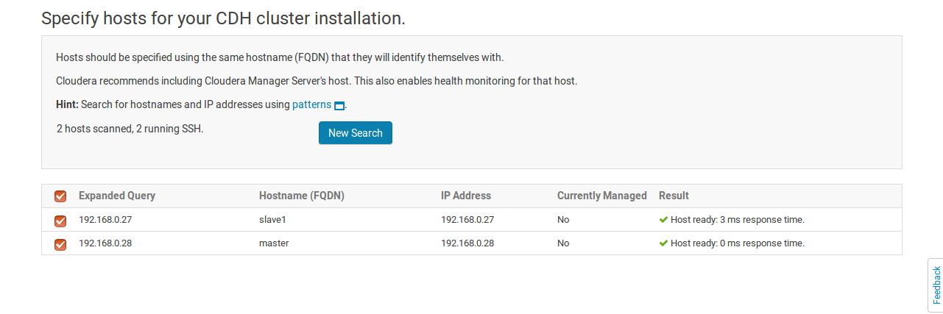

Each node containing same username and password would make the process easier.

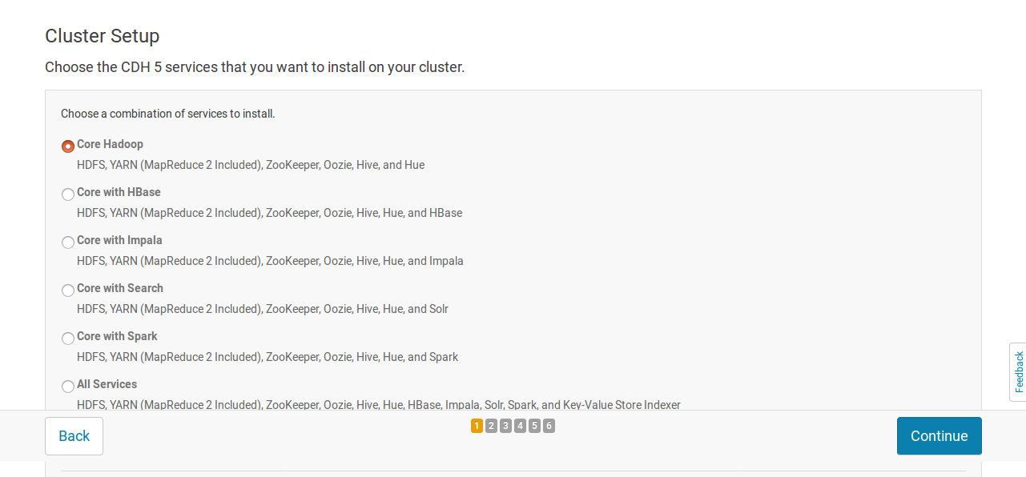

Manually distribute role instances to nodes.

(https://www.cloudera.com/documentation/enterprise/5-8-x/topics/cm_ig_host_allocations.html)

